Ques .2 - The efficiency measurement (measured in percentage) of 50 workers during a workout is given below. Perform a normality check on the data.
Ans - (performed in MINITAB – Using stat -> Basic statistics -> Normality tests )
Here, to check the normality of data, I’ve used Kolmogorov-Smirnov test that considers the hypothesis as –
Ho : The data comes from a Normal distribution.
Against
Ho : The data doesn’t comes from a Normal distribution.
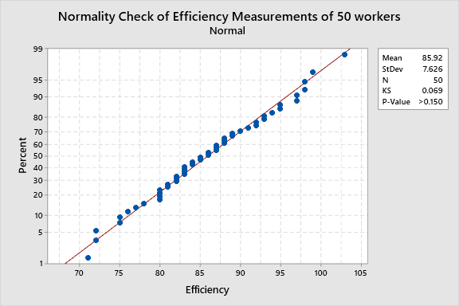
Here , P-value for K-S test came out to be >0.150 , that is definitely greater than 0.05. Hence, we do not reject our null hypothesis at 5% los . And conclude that the data comes from a normal distribution. Similary , from the normal probability Plot , we can see that the data is fitting normal distribution perfectly. Hence , Data is normally distributed.
Ques 1 . d) Carry out ANOVA method of gage R&R study using MINITAB software and interpret it.
Two-Way ANOVA Table With Interaction
Source | DF | SS | MS | F | P
Part | 9 | 0.0033004 | 0.0003667 | 29.9679 | 0.000
Operator | 1 | 0.0000486 | 0.0000486 | 3.9732 | 0.077
Part * Operator | 9 | 0.0001101 | 0.0000122 | 0.3231 | 0.957
Repeatability | 20 | 0.0007575 | 0.0000379
Total | 39 | 0.0042167
α to remove interaction term = 0.05
Here ,in the part-operator interaction the p-value for the interaction is ≥ 0.05, Hence we do not reject our hypothesis. That means interaction do not differs significantly.

Two-Way ANOVA Table Without Interaction
Source | DF | SS | MS | F | P
Part | 9 | 0.0033004 | 0.0003667 | 12.2571 | 0.000
Operator | 1 | 0.0000486 | 0.0000486 | 1.6251 | 0.213
Repeatability | 29 | 0.0008676 | 0.0000299
Total | 39 | 0.0042167

Variance Components
Source | VarComp | %Contribution  (of VarComp)
Total Gage R&R | 0.0000309 | 26.82
Repeatability | 0.0000299 | 26.00
Reproducibility | 0.0000009 | 0.81
Operator | 0.0000009 | 0.81
Part-To-Part | 0.0000842 | 73.18
Total Variation | 0.0001151 | 100.00

the %Contribution column in the Gage R&R table shows that the variation from Part-To-Part is 73.18%. This value is much larger than Total Gage R&R, which is 26.82%. Thus, much of the variation is due to differences between parts.

Gage Evaluation
Source | StdDev (SD) | Study Var  (6 × SD) | %Study Var  (%SV)
Total Gage R&R | 0.0055546 | 0.0333276 | 51.79
Repeatability | 0.0054698 | 0.0328187 | 50.99
Reproducibility | 0.0009670 | 0.0058020 | 9.02
Operator | 0.0009670 | 0.0058020 | 9.02
Part-To-Part | 0.0091760 | 0.0550560 | 85.55
Total Variation | 0.0107263 | 0.0643576 | 100.00

